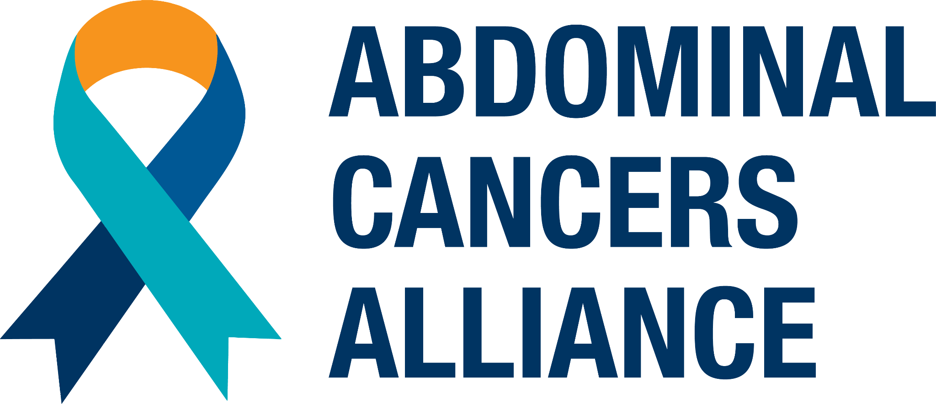

Dear *[recipient’s name]*,

I hope this message finds you well. I’m reaching out because I am asking for your help supporting a cause that is very close to my heart. I’m joining with the Abdominal Cancers Alliance to support those who are diagnosed with rare and advanced abdominal cancers, and I would love for you to be a part of this mission with me.

*[insert your personal “why” here, such as: As you may or may not know, I was diagnosed with stage-xxxx appendix cancer several years ago.]* Appendix cancer is rare, often overlooked, and often diagnosed at very late stages. It affects fewer than 2 people per million each year. Because it’s so rare, many patients face delayed diagnoses - including cases that go undiagnosed or are misdiagnosed - and symptoms are vague or misunderstood. I want to see that change and we can help make it happen!

I have joined this campaign to raise funds and raise awareness about appendix cancer and the lifesaving treatment options available to treat it - especially the CRS/HIPEC procedure. This critical treatment option is saving lives every day, but is still unknown in much of our medical community. *[insert your personal connection here, such as: CRS/HIPEC is the only reason I’m still here today after I was diagnosed with appendix cancer several years ago.]* The Abdominal Cancers Alliance is dedicated to advocating for patients and caregivers, raising awareness with the public and care providers, and helping patients facing these rare and advanced cancers find the appropriate care they need.

**Here’s how you can help make a difference:**

My goal is to raise $*[x]*, and any amount you can contribute - $50, $100, $250, $500, or more - helps bring visibility to this rare cancer and what to do about it, improves education and advocacy, and gives patients and caregivers much-needed hope. Your support is not just a donation, it is fuel for our mission to make sure that every patient receives timely and appropriate care throughout their journey.

I also challenge you to help me reach more people with this mission! The more folks we reach, the more awareness we raise - that means more patients advocating for themselves, more correct diagnoses, more chances at curative treatment, and more lives saved. Even if someone can’t contribute to this campaign, simply spreading the word makes a real difference.

If you’d like to support my campaign, you can do so by visiting my personal fundraising page here: *[insert your page’s link here]* Also, if your employer offers matching donations, this is a great way to maximize your impact!

I’ll check in with you next week to follow up, but please don’t hesitate to reach out if you have any questions. Since the Abdominal Cancers Alliance, an initiative of Partners for Cancer Care and Prevention, is a 501(c)(3) nonprofit, your donation is tax-deductible.

I truly appreciate your generosity and support. Together, we CAN make a difference.

With gratitude,

*[your name]*

